**BASH SCRIPTING**

**CREATE ON BASH SCRIPT TO CHECK IF A DIRECTORY IS AVAILABLE OR NOT**

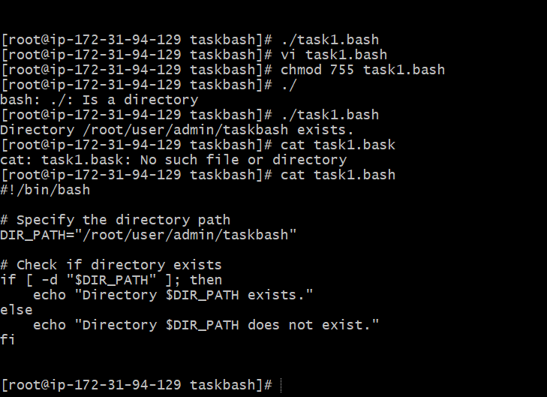

CREATE A BASH SCRIPT WHICH WILL CREATE MULTIPLE FILES

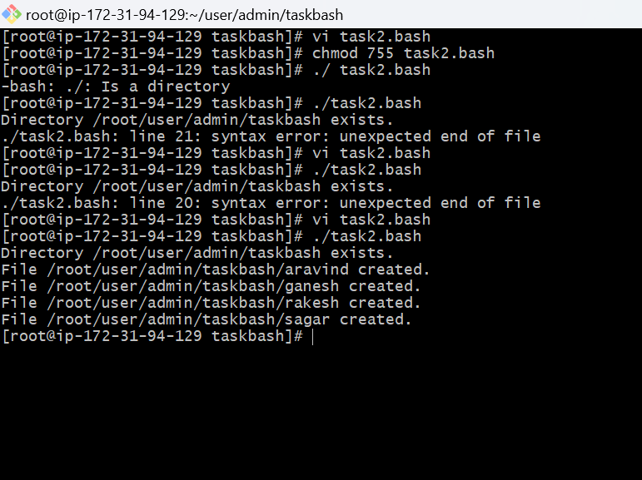

CREATE A BASH SCRIPT TO TAKE BACKUP OF A DIRECTORY

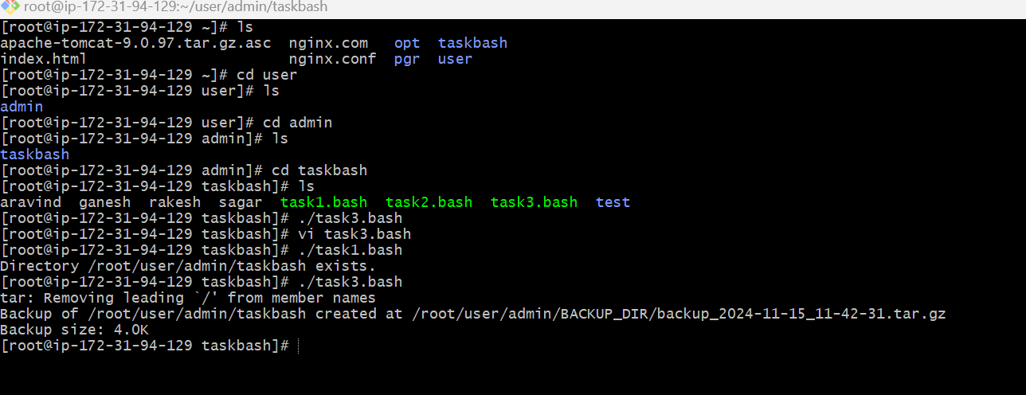

CREATE A BASH SCRIPT TO INSTALL NGINX IN EC2 SERVER

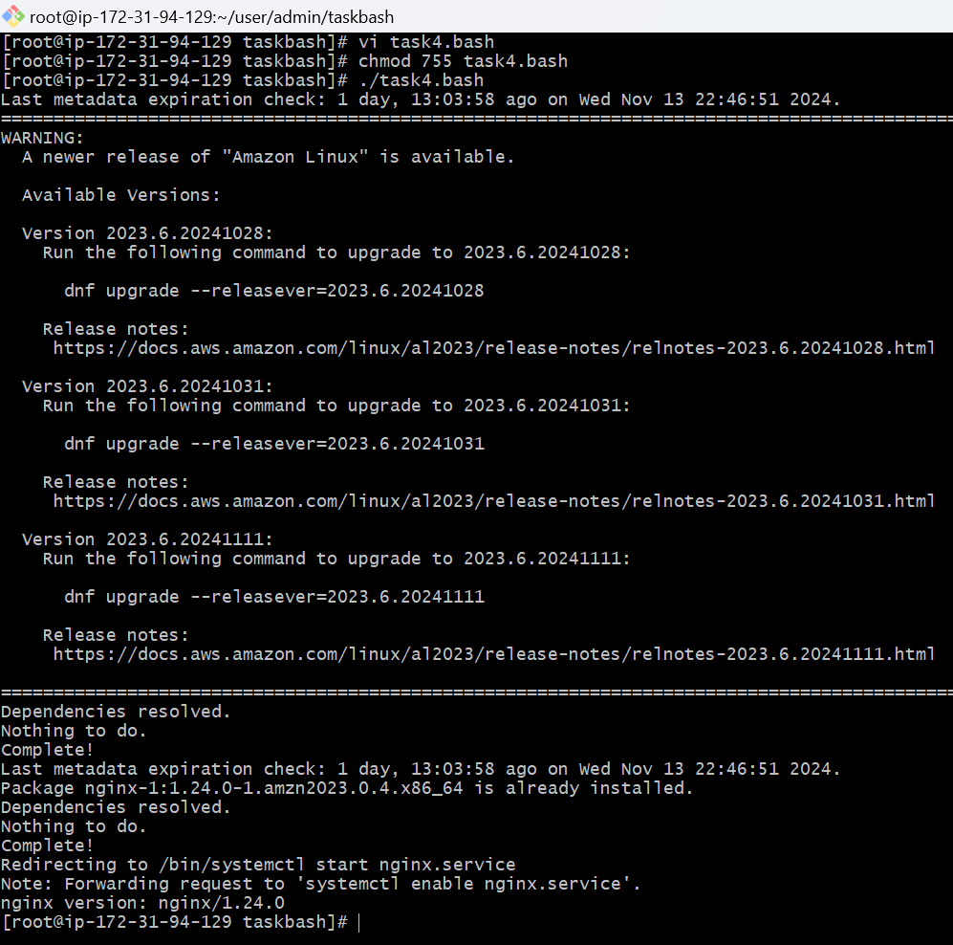

CREAT A BASH SCRIPT TO INSTALL APACHE TOMCAT IN EC2 SERVER

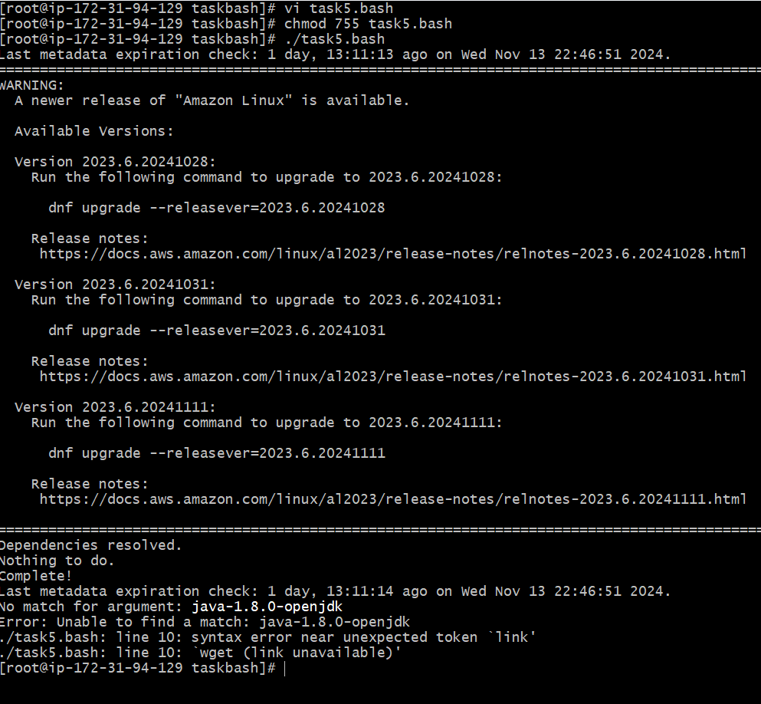

CREATE A BASH SCRIPT TO CHECK LIST IF NGINX SERVICE IS RUNNNING OR NOT RUNNING THEN SCRIPT SHOULD START THE SERVICE

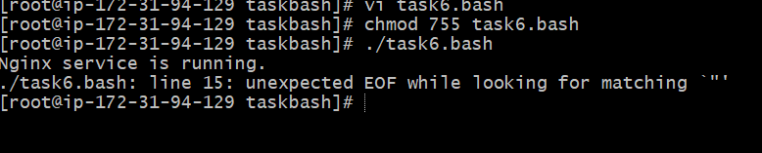

CREATE A BASH SCRIPT FOR CALCULATOR

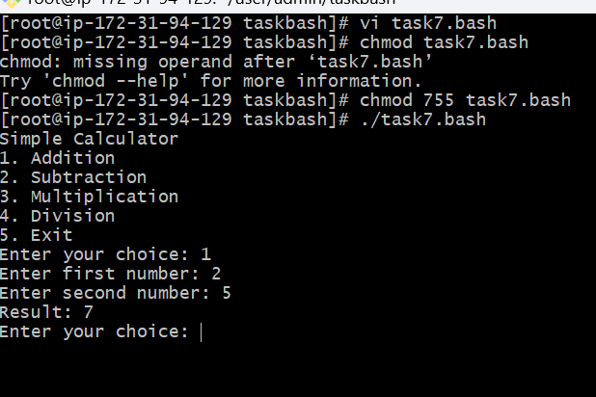

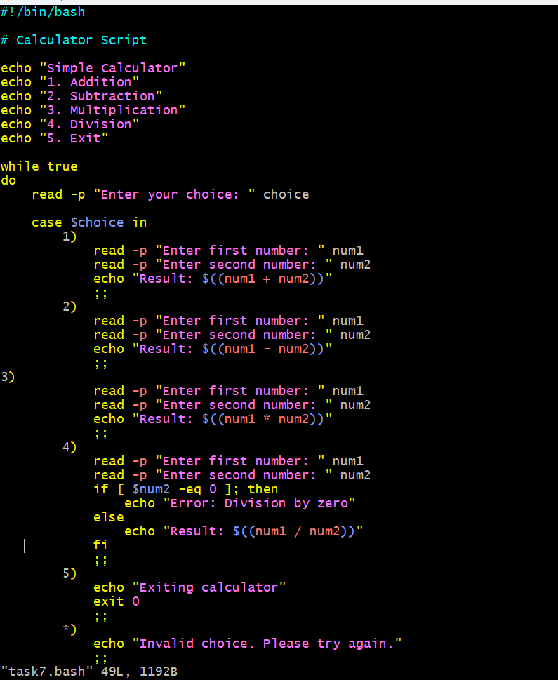



CREATE A BASH SCRIPT TO CHECK IF DIRECTORY IS AVALABLE OR NOT IF NOT THEN CREATE A DIRECTORY

